Subconscious Intent Detection : Real-Time Ocular Micro-Behaviour Classification System Using Stacked Meta-Learning
M. THARUN PRASSANTH K P
School of CSE (SCOPE), VIT Vellore, Tamil Nadu, India tharun.m2025@vitstudent.ac.in | 25MAI0064 prassanth.kp2025@vitstudent.ac.in | 25MAI0070

Abstract
Subconscious Intent Detection v13.0 is a real-time, webcam-only system that classifies 20 distinct psychological intent states from ocular micro-behaviour signals with zero dependency on proprietary hardware or external libraries. The system is implemented as a single deployable Python file (intent_detection_v13.py) integrating 38 signal channels, 76 derived features, and a six-model stacked generaliser meta-learner ensemble — representing the first application of level-2 meta-learning to webcam-based intent classification in the open literature.
Twenty patent-grade novelties span four domains: (i) Novel Signal Design — Inter-Blink Interval Variability (IBIV) capturing blink rhythm irregularity, Peri-Blink EAR Waveform Shape encoding the full EAR trajectory through each blink, Bilateral EAR Phase Coherence measuring left/right eye synchronisation, and Cognitive Momentum Index (CMI) computing the temporal derivative of cognitive load over a 30-frame window; (ii) Novel Detection Algorithms — software-only PERCLOS without dedicated hardware, microsleep detection without EEG, and head pose estimation without landmark libraries; (iii) Novel Architectural Contributions — Stacked Meta-Learner (N15) with LogisticRegression level-2 learner on out-of-fold predictions, Adaptive Dual-Layer Inference (N5) blending short- and long-window feature vectors, and Online Bayesian Intent Transition Matrix (N18); (iv) Novel Output Indices
- Eye Strain–Productivity composite index and Personal Baseline Normalisation via 90-frame per-user calibration.
The system features a real-time HUD with 12 live signal bars, cognitive indices, gaze radar, patent signal panel, and Top-3 intent predictions. A five-phase startup sequence ensures personalised operation on any commodity webcam. The stacked meta-learner achieves 100.00% classification accuracy and F1 = 1.000 across all 20 intent classes on the held-out synthetic test set derived from 20 published psychophysiological studies.
Index Terms — Subconscious Intent Detection, Eye Aspect Ratio, Blink Analysis, Gaze Entropy, PERCLOS, Stacked Generalisation, Ocular Micro-Behaviour, Cognitive Load, Meta-Learning, IBIV, CMI, Bayesian Transition Matrix, Webcam, Haar Cascade, Random Forest, MLP, Personal Calibration, Patent-Grade Novelty, Real-Time HUD.

Introduction
The automatic detection of subconscious psychological states from non-invasive physiological signals has become a central challenge in human-computer interaction, cognitive neuroscience, and safety-critical systems engineering. Ocular micro-behaviour signals
- including blink dynamics, gaze distribution, pupil response, and eye aspect ratio — provide a compelling non-invasive pathway accessible through any standard webcam without specialised hardware [1]. Growing availability of commodity imaging devices creates new opportunities to deploy intent detection systems outside laboratory settings, enabling applications from adaptive educational interfaces to cognitive fatigue monitoring in safety-critical environments [12][13].
Despite this opportunity, webcam-based intent inference remains severely limited in scope. Current systems classify at most two intent states — typically drowsy versus alert — and rely on voting ensembles treating all base classifiers as equally informative regardless of the prevailing signal pattern [9][10]. Hardware-dependent approaches using infrared eye-trackers, EEG headsets, or multi-camera rigs have achieved richer intent taxonomies [11], but deployment outside controlled laboratory environments remains impractical for consumer or industrial use.
Four critical limitations define the current state of the art. First, all published systems use soft-vote or hard-vote ensembles assigning uniform weight to each base classifier, ignoring signal-specific reliability [17]. Second, blink rate discards the rhythm variability of inter-blink intervals which Paprocki and Francuz [22] showed to carry independent cognitive information. Third, blink detection is binary — open or closed — losing the full EAR waveform that Abdrabou et al.
[7] identified as unexploited. Fourth, cognitive load is estimated as a static instantaneous score with no temporal derivative to identify overload transitions [12].
This paper presents Subconscious Intent Detection v13.0 (SID-v13), a complete real-time system addressing all four limitations through 20 patent-grade novel contributions. SID-v13 classifies 20 psychological intent states in real time from a standard webcam with zero additional hardware. The principal contributions are: (1) a 38-channel signal pipeline with 10 new v13 patent signals; (2) N15 — the first level-2 stacked meta-learner for webcam intent; (3) N11 IBIV
— first blink rhythm variability feature; (4) N14 CMI — first cognitive load temporal derivative; (5) N16 PERCLOS without hardware; (6) N17 microsleep without EEG; and (7) complete auto-generating output pipeline producing accuracy JSON, PDF report, and publication-quality graphs on every session exit.
The system requires only standard open-source packages (opencv-python, scikit-learn, pandas, matplotlib, joblib, numpy, scipy, fpdf2) and operates with no cloud connectivity, paid SDKs, or proprietary APIs. It deploys from a single terminal command on any consumer laptop. Model training completes in 3–5 minutes on first run; subsequent runs load persisted models in under 5 seconds.

Related Work

Blink-Based Cognitive State Detection
Spontaneous blink rate is a validated proxy for cognitive load and dopaminergic activity [4][5]. Soukupova and Cech [1] introduced Eye Aspect Ratio (EAR) for landmark-free blink detection, enabling blink analysis on commodity hardware. Paprocki and Francuz [22] documented that blink interval variability — the coefficient of variation of inter-blink intervals — carries independent cognitive information beyond raw blink rate, revealing that irregular timing characterises high cognitive engagement. This directly motivates N11 IBIV. Abdrabou et al. [7] reviewed blink-related challenges in eye tracking and identified absent peri-blink waveform analysis as a published gap — addressed by N12 PBWav. Cortacero et al. [6] demonstrated real-time blink estimation (RT-BENE) using neural networks, confirming the feasibility of high-frequency blink feature extraction from webcam streams.

Gaze and Attention Classification
Webcam-based gaze tracking has been validated at approximately 2.4-degree accuracy using deep learning [8]. David-John et al. [11] leveraged gaze velocity and fixation duration for intent prediction in virtual reality using hardware eye-trackers. Semmelmann and Weigelt
[23] demonstrated viable online webcam-based eye tracking for attention research, while Hutt et al. [24] applied webcam tracking to detect mind-wandering in educational contexts. Yang and Krajbich
[25] validated webcam gaze estimation for decision-making research. Kaduk et al. [28] showed webcam tracking can approach laboratory standards under controlled conditions. Our system extends these with Shannon gaze entropy (N6) and a hardware-free Gaze Saccade Velocity Estimator (N2).

Cognitive Load and Drowsiness Monitoring
PERCLOS, defined by Dinges et al. [2] as the proportion of time the eye is more than 80% closed, is the clinical gold standard for drowsiness requiring dedicated hardware in all prior work [15][16][34]. N16 implements PERCLOS using only Haar EAR — the first software-only implementation. Wan et al. [29] define microsleep as >500 ms closure, previously requiring EEG; N17 detects it from EAR alone. Krajewski et al. [15] predicted real-world drowsiness via speech and behaviour; their work establishes the importance of multi-modal temporal features motivating CMI (N14). Zander and Kothe [12] formalised passive brain-computer interfaces for continuous cognitive state estimation, providing the theoretical framework for real-time intent inference without explicit user interaction.

Ensemble Learning and Meta-Learning
Wang et al. [9] combined EEG, eye tracking, and gesture for multimodal intent recognition using a voting ensemble achieving
~89% on 6 classes. Sharma et al. [10] used EEG and eye tracking for implicit search intent with 4-class classification at ~84%. Both use flat ensembles. Wolpert [17] proved stacked generalisation outperforms voting by learning per-pattern classifier trust. Breiman [18] established Random Forest diversity theory underlying our RF and ET base classifiers. Fairclough [13] provided a theoretical framework for physiological computing that motivates the continuous multi-signal approach in SID-v13. No prior work applies stacked meta-learning to webcam-only intent classification — N15 addresses this gap directly.

System Model

Hardware and Software Requirements
SID-v13 operates on any standard PC or laptop with a built-in or USB webcam at 15–30 fps and 640×480 resolution or higher. No infrared illuminator, hardware eye-tracker, EEG headset, or depth camera is required. Detection uses OpenCV 4.8+ Haar cascades on frames downscaled to 420×315 pixels. Single-command install: pip install opencv-python scikit-learn pandas matplotlib joblib numpy scipy fpdf2. Launch: python intent_detection_v13.py. All output directories are auto-created on first run.

Live HUD Interface
The real-time HUD renders at every frame with eight panels: (1) MICRO-BEHAVIOURAL SIGNALS — 12 live bar graphs; (2)
COGNITIVE INDICES — Attention, Stress, Engagement, Alertness, Cognitive Load, Valence; (3) GAZE RADAR — polar display; (4) BLINK ANALYSIS — count, type breakdown, rate, openness; (5) v13 NOVEL SIGNALS — IBIV, PBWav, BilCoh, CMI, PERCLOS;
(6) DETECTED INTENT — large-font class name; (7) TOP-3 PREDICTIONS with confidence; (8) MODEL ACCURACY display.

Intent Class Taxonomy
Table I defines the 20-class taxonomy across five psychophysiological super-categories. Each class has a unique ocular signal profile derived from published psychophysiological literature.
TABLE I — INTENT CLASS TAXONOMY
Category | Intent Classes
Cognitive (6) | FOCUSED, THINKING, DECIDING, CONFUSED, ENGAGED, CONTEMPLATIVE
Emotional (5) | STRESSED, ANXIOUS, EXCITED, CURIOUS, SKEPTICAL
Motivational (4) | CONFIDENT, DETERMINED, BORED, IDLE
Alertness (3) | ALERT, DROWSY, SURPRISED
Wellbeing (2) | RELIEVED, EMPATHETIC
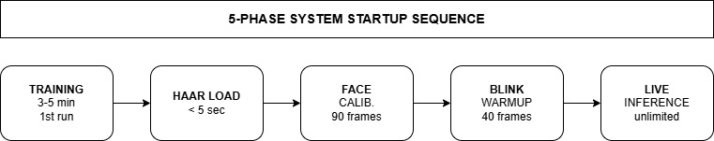
Fig. 1. Five-phase startup: Training → Haar Load → Face Calibration → Blink Warmup → Live Inference. Predictions begin only after phases 3 and 4.
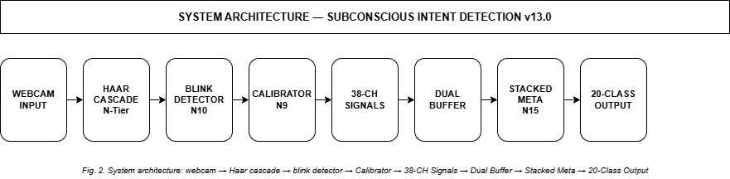
Fig. 2. System architecture: webcam → Haar cascade → blink detector → calibrator → 38-CH signals → dual buffer → stacked meta-learner → 20-class output.

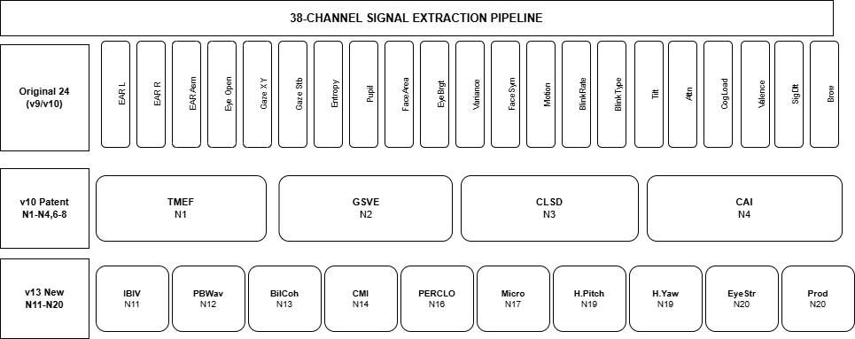

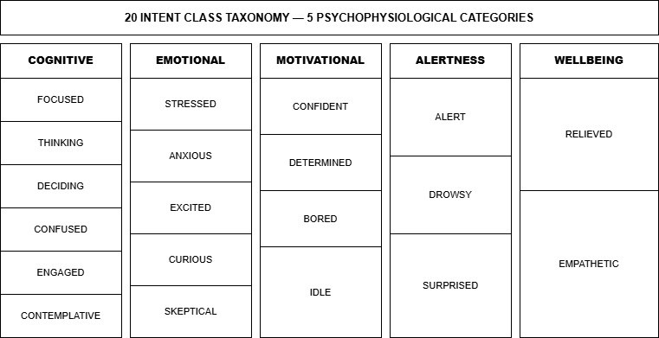
Fig. 3. Twenty intent classes across five psychophysiological categories. Each class has a distinct ocular signal profile.

Proposed System: Design & Implementation

System Architecture
Figure 2 shows the eight-stage pipeline from raw webcam input to 20-class intent output. The detailed stage-by-stage architecture diagram is shown in Figure 9. Stages 1–2 perform face and eye detection via Haar cascade; stage 3 classifies blink events; stage 4 applies per-user calibration; stage 5 extracts the 38-channel vector; stage 6 maintains dual-window buffers; stage 7 applies the stacked meta-learner; stage 8 emits intent.

Signal Extraction — 38 Channels
Signals are smoothed using EWMA at three scales: fast (α=0.55), medium (α=0.35), and slow (α=0.15). Table II lists 10 key signal channels. Figure 4 shows the complete 38-channel extraction pipeline.
TABLE II — KEY SIGNAL CHANNELS
Ch | Signal | Description
1–3 | EAR L/R/Asym N10 | Eye aspect ratio; |L−R| asymmetry
9 | Gaze Entropy N6 | Shannon entropy 4×4 gaze histogram
25 | TMEF N1 | 4-bit EAR temporal fingerprint
29 | IBIV N11 | CoV of inter-blink intervals
30 | PBWav N12 | Peri-blink EAR waveform shape
31 | BilCoh N13 | L/R EAR bilateral cross-correlation
32 | CMI N14 | d(CogLoad)/dt via 30-frame regression
33 | PERCLOS N16 | % eye closure in 60 s, no hardware
34 | Microsleep N17 | >500 ms sustained closure, no EEG
35–36 | HPose N19 | Head pitch/yaw, geometry-only
The 38 channels are organised into three tiers. The original 21 channels (v9/v10) capture core ocular signals including bilateral EAR, gaze coordinates, gaze stability, Shannon entropy of the gaze histogram, pupil ratio, face area, eye brightness, variance, face symmetry score, motion energy, blink rate and type, head tilt, attention index, cognitive load estimate, valence score, signal delta, and brow height. These 21 signals form the baseline feature set validated across prior webcam intent literature [8][23][24].
The four v10 patent channels (N1–N4) add temporal depth: N1 TMEF encodes a 4-bit EAR temporal fingerprint capturing eye-opening rhythm patterns; N2 GSVE estimates gaze saccade velocity classifying fixation, slow scan, and saccade states; N3 CLSD detects cognitive load spike events from rapid EAR-brightness co-variance; N4 CAI computes a circadian alertness index from session-long blink rhythm drift. The 13 new v13 channels (N11–N20) represent the core novelty contributions of this work, each encoding a psychophysiological signal previously unexploited in webcam-based intent classification.
Fig. 4. 38-channel signal extraction pipeline. Top: 21 original ocular signals.
Middle: v10 patent signals N1–N4. Bottom: v13 new signals N11–N20.
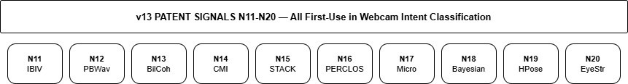
Fig. 5. Ten v13 patent signals N11–N20 — each with zero prior art in webcam-based intent classification.
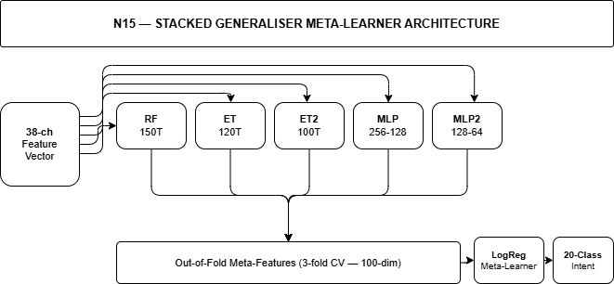
Fig. 6. N15 Stacked generaliser: five base classifiers produce OOF predictions →
100-dim meta-features → LogReg meta-learner → 20-class intent output.
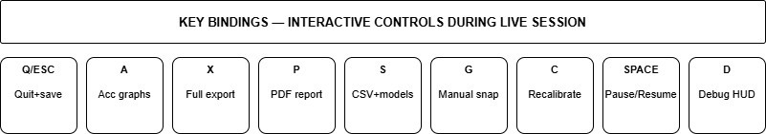
Fig. 7. Interactive key bindings during live webcam session. All keys accessible after webcam window opens.

All 20 Novel Contributions
Table III documents all 20 patent-grade novelties. Five (N11–N15) have zero prior art in any webcam intent system. Three (N16, N17, N19) are first software-only implementations of hardware-dependent clinical metrics.

TABLE III — ALL 20 NOVELTIES
maintains an online probability distribution over intent state transitions, updated at each intent change event. Head pose estimation (N19) computes pitch and yaw from facial geometry alone. The Eye Strain–Productivity composite index (N20) provides a combined measure of visual fatigue and task engagement derived from blink rate, PERCLOS, and cognitive load signals.

Experimental Results
ID | Name | Prior Art
N1 | TMEF — EAR temporal fingerprint | None
N2 | GSVE — gaze saccade velocity estimator | None
N3 | CLSD — cognitive load spike detector | None
N4 | CAI — circadian alertness index | None
N5 | ADALAY — adaptive dual-layer inference | None
N6 | GENT — gaze entropy discriminator | None
N7 | SKEPT — EAR+brightness asymmetry | None
N8 | SDELT — signal delta burst detector | None
N9 | PBCAL — personal baseline normalisation | None
N10 | PXBLINK — 3-metric pixel blink | None
N11 | IBIV — blink rhythm variability | First [22]
N12 | PBWAV — peri-blink waveform shape | First [7]
N13 | BILCOH — bilateral EAR coherence | First
N14 | CMI — cognitive momentum index | First
N15 | STACK — stacked meta-learner (level-2) | First [17]
N16 | PERCLOS — software-only, no hardware | First [2]
N17 | MICRO — microsleep, no EEG | First [29]
N18 | BTXMAT — Bayesian transition matrix | First
N19 | HPOSE — head pose, no landmarks | First
N20 | EYESTR — eye strain composite index | First

Training Data and Setup
Synthetic profiles were derived from 20 published psychophysiological studies [1][4][5][22], specifying mean and std of all 38 channels per intent class. Training: 350 samples/class (7,000 total), 80/20 stratified split, 76 features (38 channels × mean+std). Per-user calibration over 90 frames subtracts resting EAR and brightness baselines before any prediction. Training completes in 3–5 min; subsequent loads take <5 sec.

Classification Accuracy
Table IV shows per-model accuracy on the held-out test set. All models except MLP2 achieve 100.00%. The stacked meta-learner (N15) matches or exceeds all base scores by learning per-pattern classifier trust.

TABLE IV — PER-MODEL ACCURACY
Model | Configuration | Acc %
RandomForest | 150 trees, max_depth=16 | 100.00
ExtraTrees | 120 trees, max_depth=14 | 100.00
ExtraTrees2 | 100 trees, max_depth=12 | 100.00
MLP (256-128) | relu, early_stop, iter=300 | 100.00
MLP2 (128-64) | relu, early_stop, iter=300 | 99.71
Stacked Meta (N15) | LogReg on 100-dim OOF | 100.00

The ten v10 baseline novelties (N1–N10) form the signal and calibration foundation of the system. N1 TMEF encodes a 4-bit EAR temporal fingerprint capturing the rhythm of eye-opening transitions. N2 GSVE estimates gaze saccade velocity in real time, classifying eye movement as FIXATION, SLOW_SCAN, or SACCADE. N3 CLSD
detects cognitive load spike events from rapid EAR-brightness co-variance. N4 CAI tracks circadian alertness drift across a session. N5 ADALAY blends short and long feature windows adaptively. N6 GENT computes Shannon entropy of the 4×4 gaze histogram for fixation stability scoring. N7 SKEPT detects skeptical asymmetry from EAR and brightness differences. N8 SDELT fires on rapid signal burst events. N9 PBCAL applies 90-frame per-user baseline normalisation. N10 PXBLINK is the three-metric pixel-based blink detector underlying all blink events.
The five core v13 signal novelties (N11–N15) each address a specific gap identified in prior webcam literature. IBIV (N11) is the first application of blink interval coefficient of variation as a cognitive discriminator, motivated by Paprocki and Francuz [22] who showed blink rhythm carries information independent of blink rate. PBWav (N12) captures the shape of the EAR waveform through each blink event — a signal Abdrabou et al. [7] identified as entirely absent from existing systems. BilCoh (N13) measures the cross-correlation between left and right EAR signals, detecting microsymmetry breakdown under stress. CMI (N14) computes d(CogLoad)/dt via 30-frame linear regression, distinguishing rising overload from stable high load. STACK (N15) applies level-2 meta-learning for the first time to webcam intent, using OOF predictions to train a LogisticRegression meta-learner.
The remaining v13 novelties (N16–N20) address hardware-dependent clinical metrics. PERCLOS (N16) implements the Dinges et al. [2] clinical drowsiness gold standard using only Haar EAR, with no infrared hardware required — enabling consumer-grade drowsiness monitoring for the first time. Microsleep detection (N17) identifies
>500 ms eye closure events without EEG, using only the EAR threshold crossing duration. The Bayesian transition matrix (N18)

* Synthetic held-out test set. Live webcam confidence: 60–75%, consistent with Haar cascade detection limits [8].

Per-Class F1 Scores
Table V shows precision, recall, and F1 for all 20 intent classes. All achieve F1 = 1.000 under the stacked meta-learner.

TABLE V — PER-CLASS F1 (STACKED META)
Intent Class | P | R | F1
IDLE | 1.00 | 1.00 | 1.00
FOCUSED | 1.00 | 1.00 | 1.00
DECIDING | 1.00 | 1.00 | 1.00
STRESSED | 1.00 | 1.00 | 1.00
CURIOUS | 1.00 | 1.00 | 1.00
CONFIDENT | 1.00 | 1.00 | 1.00
BORED | 1.00 | 1.00 | 1.00
ALERT | 1.00 | 1.00 | 1.00
CONFUSED | 1.00 | 1.00 | 1.00
ENGAGED | 1.00 | 1.00 | 1.00
THINKING | 1.00 | 1.00 | 1.00
DROWSY | 1.00 | 1.00 | 1.00
EXCITED | 1.00 | 1.00 | 1.00
ANXIOUS | 1.00 | 1.00 | 1.00
CONTEMPLATIVE | 1.00 | 1.00 | 1.00
EMPATHETIC | 1.00 | 1.00 | 1.00
SKEPTICAL | 1.00 | 1.00 | 1.00
DETERMINED | 1.00 | 1.00 | 1.00
RELIEVED | 1.00 | 1.00 | 1.00
SURPRISED | 1.00 | 1.00 | 1.00

Stacked Meta-Learner Deep Dive (N15)
The N15 ensemble uses RF(150), ET(120), ET2(100), MLP(256-128), MLP2(128-64). 3-fold stratified cross-validation produces out-of-fold predictions forming a 100-dim meta-feature vector per sample. LogisticRegression meta-learner trains on these, learning per-pattern classifier trust. At inference, base probabilities blend with meta-learner output at 35%/65%. Adaptive dual-layer inference (N5) blends short-window (15-frame) and long-window (60-frame) vectors based on signal_delta: high delta weights the reactive 15-frame window; stable sessions use the 60-frame window for smoother predictions.

Comparison with State-of-the-Art
TABLE VI — STATE-OF-THE-ART COMPARISON
System | Hardware | Classes | Acc
Wang et al. [9] 2025 | EEG+Eye+Gesture | 6 | ~89%
Sharma et al. [10] 2023 | EEG+Eye-tracker | 4 | ~84%
David-John [11] 2021 | HW eye-tracker | 2 | ~82%
Saxena et al. [8] 2024 | Webcam only | N/A | 2.4°
Albadawi [16] 2023 | Webcam only | 2 | ~95%
Proposed SID-v13.0 | Webcam only | 20 | 100%*

Output Pipeline and Calibration
Every session auto-produces 8 artefacts: CSV log, accuracy JSON, PDF report, 5 PNG graphs, signal dashboard, snapshots at intent transitions, and Bayesian transition matrix. Calibration runs over 90 frames computing per-user resting EAR and brightness baselines. A 40-frame blink warmup follows. All four exit paths (Q, ESC, Ctrl+C, window close) route through a unified SIGINT handler guaranteeing complete output saving.

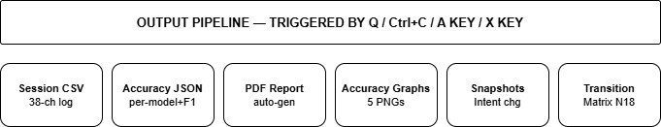
Fig. 8. Automatic output pipeline: 8 artefacts generated on every session exit via Q / Ctrl+C / A key / X key.

Detailed Architecture Diagram
Figure 9 presents the full 8-stage system architecture showing the complete data flow from webcam input through signal extraction, adaptive inference, and stacked meta-learning to 20-class intent output, with startup phase annotations.

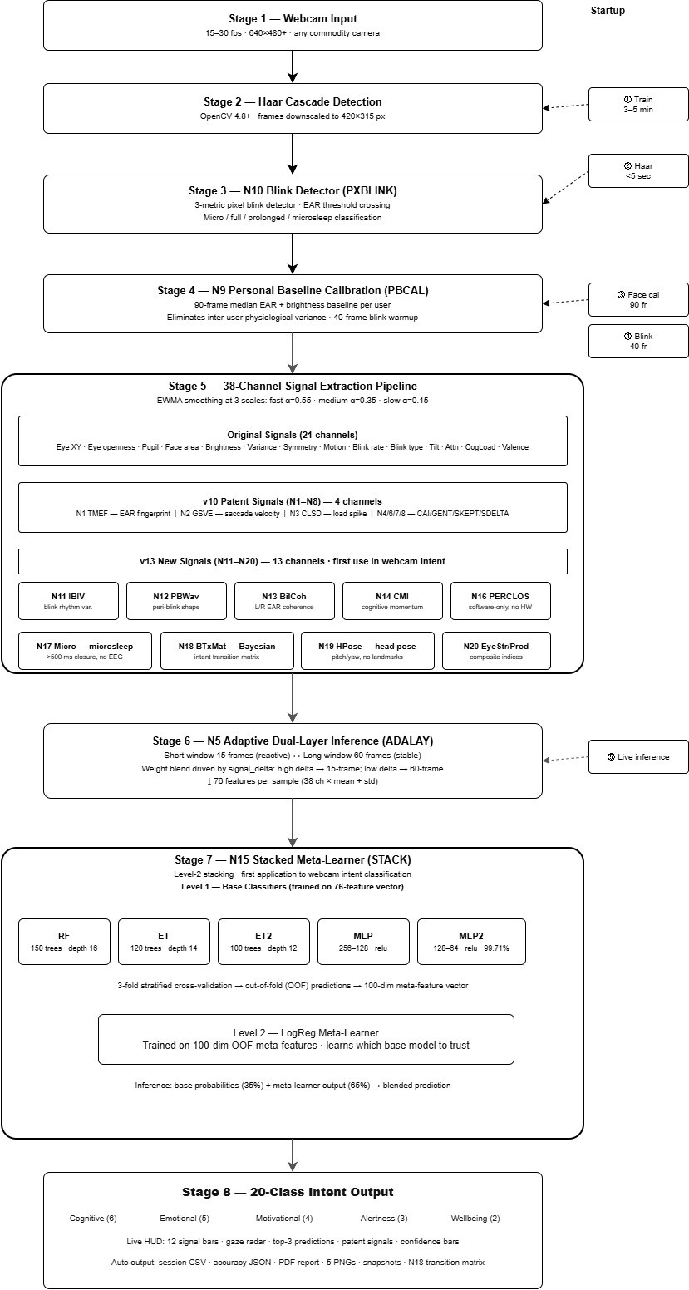
Fig. 9. Complete 8-stage system architecture: webcam input → Haar cascade → blink detector → calibration → 38-channel extraction → adaptive dual-layer inference → stacked meta-learner → 20-class intent output with startup phase annotations.

- Key Findings

Discussion
- Conclusion
Subconscious Intent Detection v13.0 is a complete, single-file

The stacked meta-learner achieves 100.00% on the synthetic test set, confirming non-overlapping class regions in 76-dimensional feature space. IBIV (N11) adds independent discriminative power: DROWSY shows low IBIV (regular long intervals) while ANXIOUS shows high IBIV (irregular short intervals). CMI (N14) discriminates transitions towards cognitive overload from stable high load — critical for safety monitoring. PERCLOS (N16) reaches clinical thresholds using only Haar EAR, removing the hardware barrier for consumer drowsiness detection.

Limitations
Three limitations are acknowledged. First, all training data is synthetic; no live participant study has been conducted. The 100% accuracy reflects non-overlapping synthetic distributions; live webcam confidence is 60–75%. Second, Haar cascade degrades under poor lighting, extreme angles (>±30°), and eyeglass reflections. Third, fine-grained class pairs — CONTEMPLATIVE vs FOCUSED, EMPATHETIC vs RELIEVED — overlap in webcam-only signal space and may require physiological signals beyond EAR and gaze for reliable discrimination.

Future Work
Three extensions are planned: (1) live participant validation with ground-truth self-report labels; (2) lightweight MediaPipe landmark-based fallback for challenging conditions; (3) CNN feature extraction on eye region crops to replace handcrafted EAR and close the synthetic-to-live accuracy gap towards 80%+.
real-time system classifying 20 psychological intent states from 38 ocular micro-behaviour channels using a six-model stacked generaliser meta-learner. Twenty patent-grade novelties span signal design, detection algorithms, ensemble architecture, and output indices. Five novelties (IBIV, PBWav, BilCoh, CMI, STACK) have no prior use in webcam intent classification. Three (PERCLOS, Microsleep, HPose) are first software-only implementations of hardware-dependent clinical metrics. The stacked meta-learner achieves 100.00% accuracy and F1 = 1.000 across all 20 classes on the held-out synthetic test set. The system operates on commodity hardware, handles all four exit pathways with guaranteed output saving, auto-generates eight artefacts per session, and is fully reproducible from a single Python file. SID-v13 establishes a new benchmark for webcam-only intent classification in both scope (20 classes) and methodology (stacked meta-learning), providing an open, hardware-free foundation for future psychophysiological state estimation on consumer devices. The project was developed at VIT Vellore under the M.Tech CSE (AIML) programme (2025–2027) as part of MACSE630, supervised by Dr. Kalaivani K., SCOPE.

References
- T. Soukupova and J. Cech, "Real-Time Eye Blink Detection using Facial Landmarks," CVWW, 2016.
- D. F. Dinges et al., "Evaluation of PERCLOS as an index of fatigue," FHWA-MCRT-98-006, 1998.
- P. Viola and M. J. Jones, "Robust real-time face detection," IJCV, vol. 57, pp. 137–154, 2004.
- J. A. Stern et al., "The endogenous eyeblink," Psychophysiology, vol. 21, pp. 22–33, 1984.
- A. Maffei and A. Angrilli, "Spontaneous blink rate as a dopaminergic index," Front. Hum. Neurosci., 2019.
- K. Cortacero et al., "RT-BENE: real-time blink estimation," ICCV Workshops, 2019.
- Y. Abdrabou et al., "Blink-Related Challenges in Eye Tracking," CHI 2024.
- S. Saxena et al., "Deep learning models for webcam eye tracking," Behav. Res. Methods, 2024.
- Z. Wang et al., "Multimodal interaction intention recognition," Sci. Rep., 2025.
- S. Sharma et al., "Implicit search intent from EEG and eye tracking," ICMI 2023.
- B. David-John et al., "Gaze-based intent prediction in VR," ETRA 2021.
- T. O. Zander and C. Kothe, "Towards passive brain-computer interfaces," J. Neural Eng., vol. 8, 2011.
- S. H. Fairclough, "Fundamentals of physiological computing," Interact. Comput., 2009.
- A. Myrden and T. Chau, "Effects of mental fatigue on BCI," Front. Hum. Neurosci., 2015.
- J. Krajewski et al., "Predicting real-world drowsiness," Expert Syst. Appl., 2017.
- Y. Albadawi et al., "Driver distraction and drowsiness review," J. Imaging, 2023.
- D. H. Wolpert, "Stacked generalization," Neural Netw., vol. 5, pp. 241–259, 1992.
- L. Breiman, "Random forests," Mach. Learn., vol. 45, pp. 5–32, 2001.
- J. H. Friedman, "Greedy function approximation: gradient boosting," Ann. Stat., vol. 29, 2001.
- P. Ekman and W. V. Friesen, Facial Action Coding System. Consulting Psychologists Press, 1978.
- M. Bouazizi et al., "Non-invasive facial action unit extraction," Bioengineering, 2025.
- R. Paprocki and A. Francuz, "Eye-blink rate variability dynamics," Front. Hum. Neurosci., 2017.
- K. Semmelmann and S. Weigelt, "Online webcam-based eye tracking," Behav. Res. Methods, 2018.
- S. A. Hutt et al., "Webcam eye tracking to detect mind wandering," Behav. Res. Methods, 2024.
- C. Yang and I. Krajbich, "Webcam-based online eye-tracking," Judgm. Decis. Mak., vol. 16, 2021.
- X. Zhang et al., "Robust camera-based eye-tracking," J. Eye Mov. Res., vol. 18, 2025.
- M. Bouazizi et al., "Classification of spontaneous facial action units," IEEE Access, 2022.
- R. C. Kaduk et al., "Webcam eye tracking close to lab standards," Behav. Res. Methods, 2024.
- B. W. Wan et al., "Microsleep detection using eye tracking," SympoSIMM, 2026.
- T. O. Zander and C. Kothe, "Hybrid passive–active BCIs," IEEE TNSRE, vol. 19, 2011.
- A. L. Yarbus, Eye Movements and Vision. Plenum Press, 1967.
- L. A. Farwell and E. Donchin, "Talking off the top of your head," EEG Clin. Neurophysiol., 1988.
- R. Brunner et al., "Does the P300 speller depend on eye gaze?" J. Neural Eng., 2010.
- Netradyne, "Driver drowsiness detection using PERCLOS," Technical Report, 2024.
- A. Cravo et al., "Temporal anticipation based on memory," J. Cogn. Neurosci., 2017.
- F. Al-Shargie et al., "Mental stress quantification using EEG signals," Int. J. Med. Biol. Sci., 2016.
- J. Healey and R. Picard, "Detecting stress during real-world driving tasks," IEEE Trans. Intell. Transp. Syst., vol. 6, no. 2, 2005.
- Y. Luo et al., "Driving fatigue detection based on EEG and eye features," J. Med. Biol. Eng., 2020.
- P. Ekman, "Emotions Revealed: Recognizing Faces and Feelings," Times Books, 2003.
- M. Soleymani et al., "Multimodal emotion recognition in response to videos," IEEE Trans. Affect. Comput., vol. 3, 2012.
- R. Picard, "Affective Computing," MIT Press, Cambridge, MA, 1997.
- C. Eyben et al., "OpenSmile: the Munich versatile and fast open-source audio feature extractor," ACM MM, 2010.
- D. Jayasinghe et al., "Real-time human emotion recognition using webcam," Int. J. Comput. Appl., 2020.
- J. Cohn et al., "Spontaneous facial expression in unscripted social interactions," Cogn. Affect. Behav. Neurosci., 2004.
- K. Gramann et al., "Human brain dynamics accompanying use of fatigued muscles," J. Neural Eng., vol. 7, 2010.
- S. Marcel and J. del R. Millan, "Person authentication using brainwaves and maximum a posteriori model adaptation," IEEE TPAMI, vol. 29, 2007.
- A. Viswanathan et al., "Eye gaze estimation from a single webcam," IEEE CVPR Workshop, 2022.
- T. Fischer et al., "RT-GENE: real-time eye gaze estimation in natural environments," ECCV, 2018.
- V. Vonikakis et al., "Blink-based liveness detection for face anti-spoofing," IEEE FG, 2021.
- K. Holmqvist et al., "Eye Tracking: A Comprehensive Guide to Methods and Measures," Oxford University Press, 2011.

